DRAW FLOWCHART AND WRITE ALGORITHM FOR THE FOLLOWING PROBLEM

FLOWCHART: EXP.NO: 1-A
DATE: 29/11/22
EX NO: 1 – A
DATE: 29/11/22

DRAW FLOWCHART AND WRITE ALGORITHM FOR
THE FOLLOWING PROBLEM.

STUDENT GRADE ANALYSIS

AIM:
To draw flowchart and write algorithm for the following problem.

ALGORITHM:
STEP 1: Start.

STEP 2: Get the Number of students (N)

STEP 3: Assign i = 0.

STEP 4: Check for the condition i < N.
4.1: If True, Get Name, Roll.no and Marks m1, m2, m3, m4, m5.
4.2: Calculate Total = m1 + m2 + m3 + m4 + m5 and Average = Total / 5
4.3: Display Name and Roll Number.
4.4: Check for condition avg >= 30 and avg < 50.
4.4.1: If True Display the message your grade is c" and increase i value by 1.
4.5: Check for condition avg > 50 and avg < 80
4.5.1: If True Display the message "You grade is B" and increase i value by 1.
4.6: Check for the condition avg > 80 and avg ≤ 100
4.6.1: If True Display the message. "Your grade is A" and increase i value by 1.
4.7: Check for the condition avg < 30
4.7.1: If True Display the message "Your grade is D".

STEP 5: If False, goto step 9

STEP 9: Stop.

PSEUDO CODE:

START
GET n
INITIALIZE i=0
IF i > n THEN
GET name, Roll no, m1, m2, m3, m4, m5
CALCULATE Total = m1+m2+m3+m4+m5
Average = Total /3
PRINT name , Roll no
IF avg >= 30 and avg < 50 THEN
PRINT Your grade is C
ELIF avg > 50 and avg < 80
PRINT Your grade is B
ELIF avg > 80 and avg ≤ 100
PRINT Your grade is A
ELIF avg < 30
PRINT Your grade is D
ENDIF
ENDIF i=i+1
STOP

RESULT:
  - Thus, the algorithm and flowchart are written for the given problem.

  - FLOWCHART: EXP.NO: 1-B
DATE: 29/11/22

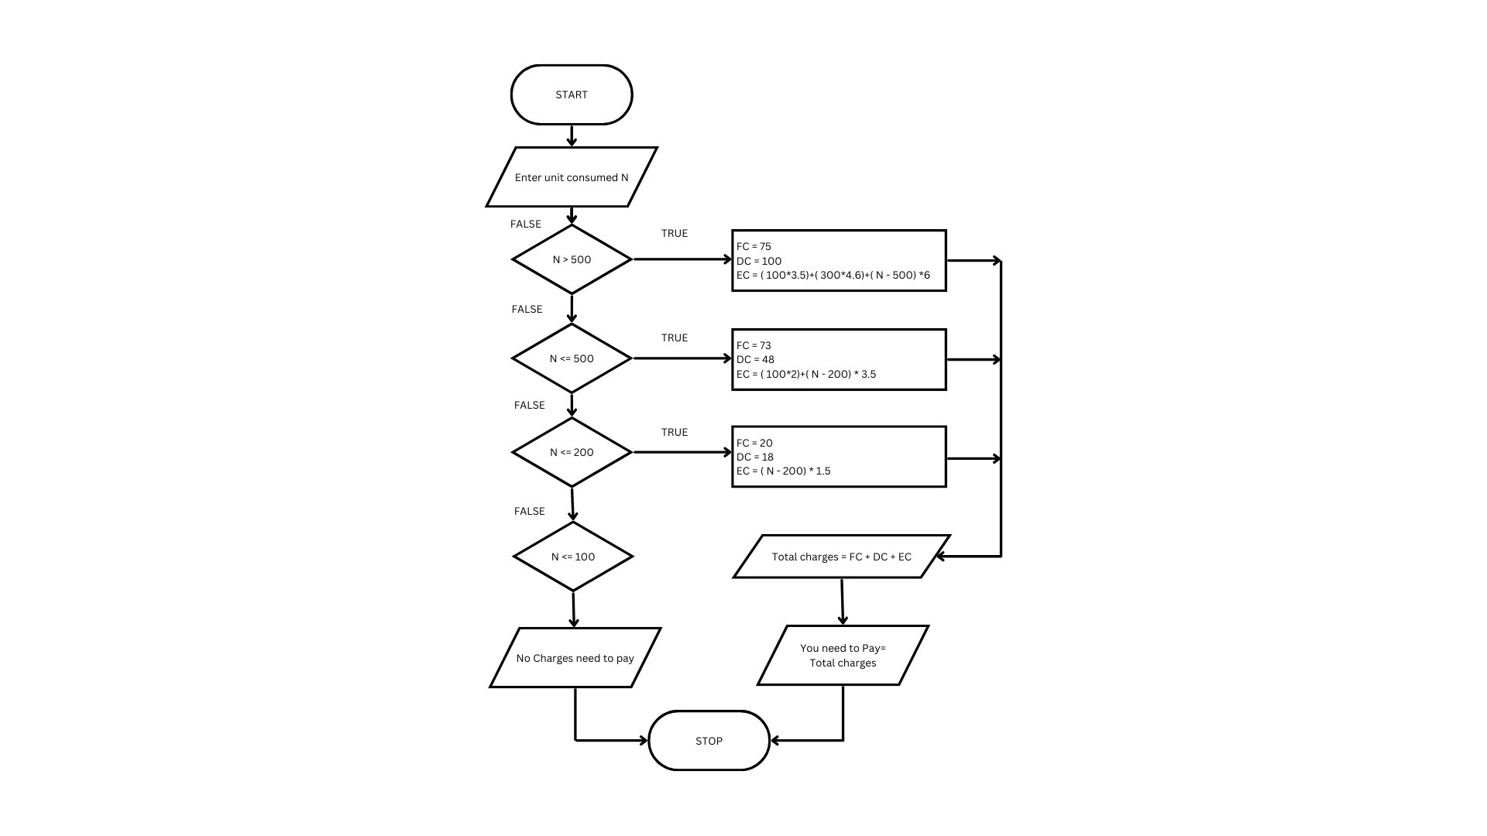
EX NO: 1 – B
DATE: 29/11/22

DRAW FLOWCHART AND WRITE ALGORITHM FOR
THE FOLLOWING PROBLEM.

CALCULATING ELECTRIC BILL

AIM:
To draw flowchart and write algorithm for calculating the electric bill.

ALGORITHM:
STEP 1: Start.
STEP 2: Enter Current Unit (CU).
STEP 3: Enter Old Unit (OU).
STEP 4: Calculate N = CU - OU
STEP 5: Check for the condition N<=100 If true.
5.1: Calculate E.C using formula. FC = 0, DC = 0, EC= 0
5.2: Calculate the Total charges = FC + DC + EC
5.3: Display amount needed to pay and go to stop.
STEP 6: Check for condition N<=200 If true.
6.1: Calculate E.C using formula FC = 20 ,DC = 18, EC = ( N – 100 ) * 1.5
6.2: Calculate the Total charges = FC + DC + EC
6.3: Display amount needed to pay and go to stop.
STEP 7: Check condition N<=500 of take.
7.1: Calculate EC using formula. FC = 73, DC = 48, EC = ( N - 100) * 3.5
7.2: Calculate the Total charges = FC + DC + EC
7.3: Display amount need to pay and goto stop.
STEP 5: Check for the condition N>500 If true.
5.1: Calculate the E.C using the formula FC = 75, DC = 100, EC = ( 400 * 4.5) + ( N - 500) * 6
5.2: Calculate Total charges = FC + DC + EC
5.3: Display the amount need to pay and go to stop

STEP 7: Stop.

PSEUDO CODE:

START
GET CU
GET OU
CALCULATE N=CU-OU
IF N<=100 THEN
FC = 0, DC = 0, EC= 0
CALCULATE EC
ELIF N<=200 THEN
FC = 0, DC = 0, EC= 0
CALCULATE EC = (N – 100) * 1.5
ELIF N<=500 THEN
FC = 0, DC = 0, EC= 0
CALCULATE EC = ( N - 100) * 3.5
ELIF N>500 THEN
FC = 0, DC = 0, EC= 0
CALCULATE EC = (400 * 4.5) + (N - 500) * 6
ENDIF
PRINT Total Charges = FC + DC + EC
STOP

RESULT:
Thus, the algorithm and the flowchart is written for the given problem.

FLOWCHART: EX NO: 1 - C
DATE: 29/11/22
EX NO: 1 – C
DATE: 29/11/22

DRAW FLOWCHART AND WRITE ALGORITHM FOR
THE FOLLOWING PROBLEM.

CALCULATE WEIGHT OF STEEL ROD

AIM:
To draw flowchart and write algorithm for calculating the weight of a steel Rod.

ALGORITHM:
STEP 1: Start.

STEP 2: Get the number of Iron nods.

STEP 3: Initialize the value I and weight as 0.

STEP 4: Chock for the condition i = n.
4.1: of true, get the diameter of the rod.
4.2: Calculate the weight-unit-weight using the formula d*2 /162 = W
4.3: Calculate the weight using the formula.
No. of rods x weight - Tw
4.4: Calculate total weight = TW+W.
4.5: Increment the value of i by 1 goto step 4.
4.1: If false display the total weight.

STEP 5: Stop

PSEUDO CODE:

START
GET n
INITIATE i=0, Weight=0
IF i = n THEN
GET d
CALCULATE W = d*2 /162
CALCULATE Tw = Tw + W i=i+1
ELSE
PRINT Tw
ENDIF
STOP

RESULT:
Thus, the algorithm and the flowchart is given for the problem.

FLOWCHART: EX NO: 1 - D
DATE: 29/11/22
EX NO: 1 – D
DATE: 29/11/22

DRAW FLOWCHART AND WRITE ALGORITHM FOR
THE FOLLOWING PROBLEM.

CALCULATE ELECTRIC CURRENT IN 3 PHASE A/C CIRCUIT

AIM:
To draw flowchart and write algorithm. to- calculate electrical current in 3 phase AC circuit.

ALGORITHM:

STEP 1: Start

STEP 2: Get value of pf (power factor)

STEP 3: Get value of Current (I).

STEP 4: Get value of voltage (V)

STEP 5: Calculate P using the formula P= √3*pf*I*V.

STEP 6: Display the value of P.

STEP 7: Stop

PSEUDO CODE:

START
GET Pf
GET I
GET V
CALCULATE P = 1.732 * I * V
PRINT P
STOP

RESULT:
Thus the flowchart and the algorithm is written for the given problem.
FLOWCHART: EX NO: 1 – E
DATE: 29/11/22
EX NO: 1 – E
DATE: 29/11/22

DRAW FLOWCHART AND WRITE ALGORITHM FOR
THE FOLLOWING PROBLEM.

CALCULATE WEIGHT OF A MOTORBIKE

AIM:
To draw flowchart and write algorithm for calculating weight of a motorbike.

ALGORITHM:
STEP 1: Start.
STEP 2: Get gross vehicle weight Rating GVWR
STEP 3: Get Dry weight (DW)
STEP 4: Get Fuel weight (FW)
STEP 5: Get Raider weight (RW)
STEP 6: Get Passenger weight (PW)
STEP 7: Calculate Total weight = DW+FW+RW+PW
STEP 8: Get Load.
STEP 9: Calculate safe weight. GVWR-Load-weight.
STEP 10: Check the condition safe weight >=0.
10.1: If true, print the message “You have a safe load and you can drive" goto stop.
10.2: If false, print the message "Reduce the load and then drive”.
10.2.1: GOTO step 8.

STEP 11: Stop.

PSEUDO CODE:

START
GET GVWR
GET DW
GET FW
GET RW
GET PW
CALCULATE Total Weight = DW + FW+ RW + PW
GET Load
CALCULATE Load Weight = Total Weight + Load
CALCULATE Safe Weight = GVWR = Load Weight
IF Safe Weight >= 0 Then
PRINT You have a safe load and you can drive
ELSE
PRINT You have excess weight, Reduce the load and then drive
ENDIF
STOP

RESULT:
Thus, the flowchart and the algorithm is written for the problem.

FLOWCHART: EX NO: 1- F
DATE: 29/11/22

EX NO: 1 – F
DATE: 29/11/22

DRAW FLOWCHART AND WRITE ALGORITHM FOR
THE FOLLOWING PROBLEM.

RETAIL SHOP.

AIM:
To draw the flowchart and write the algorithm for the retail shop billing.

ALGORITHM:
STEP 1: Start
STEP 2: Get the Bill number.
STEP 3: Get costumer name, Addr, and Ph.no.
STEP 4: Get the value of total No. of Items purchased.
STEP 5: Initialize the values for i =0, Total =0 and. subtotal =0.
STEP 6: Check if condition
6.1: If true, get Item name, Price, Quantity and the discount.
6.2: Calculate the subtotal = Qty * Price - Discount
6.3: Calculate the total = Total + Subtotal.
6.4: Increment the value of i and goto step 6.
STEP 7: of false, get the GST value.
STEP 8: Calculate Total bill amount. Total fast/100.
STEP 9: Display the Total-bill-amount,

STEP 10: Stop.

PSEUDO CODE:

START
GET Bill Number
GET custoumer name , number
INITIALIZE i=0, Total=0, Net Amount=0, Gross=0
IF I<=n
 | GET Item Name, Price, Quantity, Discount
CALCULATE The Gross = Price * quantity
CALCULATE The Disc = Gross * Discount%
CALCULATE The Net Amount = Gross-Disc
 | CALCULATE the Total = Total + Net Amount
ELSE | i=i+1
 | GET GST
 | CALCULATE GST AMOUNT = (GROSS * GST%) / 100.
 | CALCULATE the BILL Price = Net Amount + GST Amount
PRINT BILL Price
ENDIF
STOP

RESULT:
Thus the algorithm and the flowchart is written for the given program.

FLOWCHART: EX NO: 1 – G
DATE: 29/11/22
EX NO: 1 - G
DATE: 29/11/22

DRAW FLOWCHART AND WRITE ALGORITHM FOR
THE FOLLOWING PROBLEM.

SINE SERIES.

AIM:
To draw flowchart and write algorithm for the sine series.

ALGORITHM:
STEP 1: Start.
STEP 2: Get the value of x.
STEP 3: Initialize the values of 1=1, sine =0 and import moth.
STEP 4: Get the value of N.
STEP 5: Check weather value do i less than N
5.1: If condition is true, convent a to radians and adding it to y.
5.1.1: Let value of s be (-1) to the power i
5.1.2: Now calculate the series using the formula.
Sine = sine + ((y**2* i +1))/ math factorial (21+4) S.
5.1.3: Increment value of i by 1.
5.2 of condition is false display sine.

STEP 6: stop.

PSEUDO CODE:

START
GET x
INITIALIZE i=1,sine=0
IMPORT math
GET n
IF i < n
CALCULATE y = y + x ( 3.416 % 100 )
ASSIGN s = (-1) ** i
CALCULATE Sine = sine + ((y**2* i +1))/ math factorial (2*i*1) S.
i=i+1
ELSE
PRINT Sine
ENDIF
STOP

RESULT:
Thus the algorithm and flowchart written for the given problem.

